Discussion Assignment Unit 1
My favorite work of art is not a single painting or sculpture but the entire genre of abstract art. Abstract art, with its non-representational approach and emphasis on emotion, creativity, and exploration, has always captivated me and challenged my perceptions of what art can be. The genre allows for an open-ended experience that invites viewers to engage on both intellectual and emotional levels, making it my top choice for this essay (Eternal3d, 2024).
Abstract art draws its power from its ability to transcend traditional notions of representation. Rather than depicting scenes, objects, or figures as they exist in reality, abstract artists use colors, lines, shapes, forms, and textures to evoke feelings and ideas. This liberated approach is evident in the works of pioneers such as Wassily Kandinsky and Piet Mondrian, whose vibrant compositions seem to pulse with life and imagination. Kandinsky, for instance, is renowned for his swirling, dynamic use of line and color, creating a sense of rhythm and spiritual resonance that many viewers find deeply moving (Eternal3d, 2024).
The visual qualities that make abstract art my favorite are rooted in its bold experimentation with formal elements. One of the most striking aspects is the use of color. Artists like Mark Rothko and Helen Frankenthaler employed vast fields of luminous color to elicit specific emotional responses. Rothko’s paintings often consist of large, floating rectangles that seem to glow from within, enveloping the viewer in a meditative atmosphere. These color fields are not just visually arresting but also create a profound sense of space and depth, encouraging contemplation and introspection (Eternal3d, 2024).
Equally compelling is the use of line in abstract art. Jackson Pollock’s action paintings, for example, feature energetic swirls and drips that transform the surface of the canvas into a record of movement and expression. The line in Pollock’s work becomes a trace of the artist’s own physical engagement with the medium, embodying the very act of creation and allowing viewers to sense the dynamism and spontaneity behind each stroke. The result is a visual language that communicates directly to the senses, bypassing the need for recognizable imagery (Eternal3d, 2024).
Shape is another vital component in abstract compositions. Piet Mondrian’s geometric abstractions, with their grids of black lines and blocks of primary color, demonstrate how simple shapes can be orchestrated into harmonious, balanced arrangements. The clarity and order of Mondrian’s work offer a visual experience that is both calming and intellectually stimulating, illustrating how abstract art can convey meaning through pure form (Eternal3d, 2024).
For those new to abstract art, appreciating its beauty often requires letting go of expectations about what art should represent. Instead, viewers are encouraged to respond to the interplay of elements on the canvas and consider how color, line, and shape can evoke emotions or spark memories. As the genre continues to evolve and inspire new generations of artists and audiences alike, its open-ended nature remains its greatest strength (Eternal3d, 2024).
Below are images representing some of the most iconic examples of abstract art, which highlight the genre’s visual diversity and expressive power:
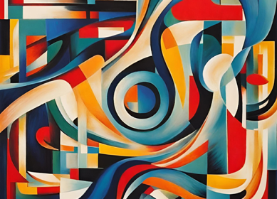 | 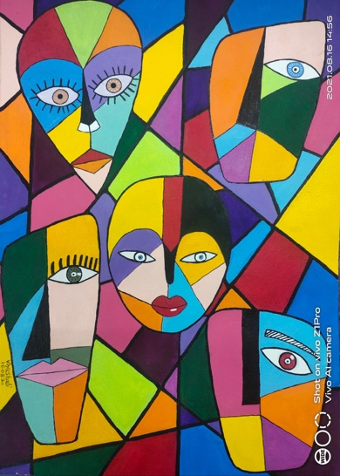 | 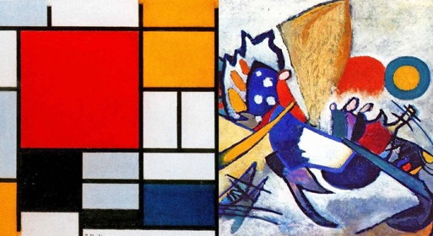

In conclusion, abstract art stands as my favorite genre because of its boundless capacity for personal interpretation, its innovative use of formal elements, and its enduring influence on the evolution of artistic expression.
Reference
Eternal3d. (2024, August 28). Famous abstract art : Unleash the power of visual expression. https://eternal3d.com/https://blog.eternal3d.com/famous-abstract-art-unleash-the-power-of-visual-expression

